[Array 19 (2023) 100294](https://doi.org/10.1016/j.array.2023.100294)

|  |  |  |
| --- | --- | --- |
|  |  |  |
|  | Contents lists available at ScienceDirect |  |
| Array |
| journal homepage: [www.sciencedirect.com/journal/array](https://www.sciencedirect.com/journal/array) |

An effective stacked autoencoder based depth separable convolutional neural network model for face mask detection   
Sundaravadivazhagan Balasubaramanian*, Robin Cyriac, Sahana Roshan,   
Kulandaivel Maruthamuthu Paramasivam, Boby Chellanthara Jose   
*University of Technology and Applied Sciences - Al Mussanah, Department of Information Technology, Al Muladdah, 314, South Al Batinah, Oman*

|  |  |
| --- | --- |
| A R T I C L E I N F O | A B S T R A C T |
| *Keywords:*  COVID-19  Stacked auto encoder  Principal component analysis  Depth-wise separable convolutional neural network  Machine learning  Deep learning | The COVID-19 pandemic has been infecting the entire world over the past years. To prevent the spread of COVID- 19, people have acclimatised to the new normal, which includes working from home, communicating online, and maintaining personal cleanliness. There are numerous tools required to prepare to compact transmissions in the future. One of these elements for protecting individuals from fatal virus transmission is the mask. Studies have indicated that wearing a mask may help to reduce the risk of viral transmission of all kinds. It causes many public places to take efforts to ensure that its guests wear adequate face masks and keep a safe distance from one another. Screening systems need to be installed at the doors of businesses, schools, government buildings, private offices, and/or other important areas. A variety of face detection models have been designed using various al-gorithms and techniques. Most of the articles in the previously published research have not worked on dimen-sionality reduction in conjunction with depth-wise separable neural networks. The necessity of determining the identities of people who do not cover their faces when they are in public is the driving factor for the development of this methodology. This research work proposes a deep learning technique to determine if a person is wearing mask or not and identifies whether it is properly worn or not. Stacked Auto Encoder (SAE) technique is implemented by stacking the following components: Principal Component Analysis (PCA) and Depth-wise Separable Convolutional Neural Network (DWSC-NN). PCA is used to reduce the irrelevant features in the im-ages and resulted high true positive rate in the detection of mask. We achieved an accuracy score of 94.16% and an F1 score of 96.009% by the application of the method described in this research. |

**1. Introduction**

Because of the tremendous advancements in science and technology, it has progressed to the point where they can perform tasks that were thought to be impossible a few decades ago. The development of tech-nologies such as Artificial Intelligence (AI) and Machine Learning (ML) has made people’s lives easier and provided solutions to a lot of difficult problems in a wide range of fields. Algorithms used in modern computer vision are growing ever closer to being able to execute tasks of visual perception on par with humans. From the classification of pictures to the analysis of videos, computer vision has proven to be a game-changing component of today’s technology. Currently, technology is a saviour for fighting viral infections and preparing ourself for any further out-breaks in the future. The concept of “work from home” has largely helped replace the traditional workday schedules in most industries and become ingrained in everyday life as a result of technological

* Corresponding author.

*E-mail address:* [sundaravadi@act.edu.om](mailto:sundaravadi@act.edu.om) (S. Balasubaramanian).

advancements. However, it is challenging for several different industries to adapt to this new norm.

People are still reluctant to go back to work even though the virus will eventually be eradicated, and such sectors are becoming increas-ingly eager to begin employing people face-to-face. 65% of workers today report feeling anxious about returning to the workplace [1]. Since the beginning of the viral pandemic, researchers from all over the world have been looking for answers and strategies that will stop the spread. The current virus travels through the respiratory system of the patient to the lung cells, where it then causes direct harm. The most effective strategy to stop the transmission of the virus is to keep distance from other people and always wear a mask when in a busy or public place.

To begin, masks are not obligatory for everybody, but researchers and medical professionals are becoming more and more inclined to propose that everyone use masks. According to the findings of several studies [2], wearing a face mask reduces the likelihood of viral

<https://doi.org/10.1016/j.array.2023.100294>   
[Received 24 January 2023; Received in revis](https://doi.org/10.1016/j.array.2023.100294)ed form 8 May 2023; Accepted 14 May 2023   
Available online 5 June 2023   
2590-0056/© 2023 The Author(s). Published by Elsevier Inc. This is an open access article under the CC BY license (<http://creativecommons.org/licenses/by/4.0/>).

*S. Balasubaramanian et al.*  *Array 19 (2023) 100294*

transmission and provides the user with a sense of safety. Face masks are recommended for use to prevent the virus from spreading. This recom-mendation comes from the World Health Organization as well as other health organisations for most viral spreads that can hurt the respiratory system. Although every government tries to mandate the use of face masks in public spaces, it might be difficult to manually identify those who are not complying with this requirement in crowded environments.

Researchers have been working to develop automated systems that can identify people using face masks in public locations and enforce their use. It is impossible to manually monitor this policy on a large scale and keep track of any infractions because of the large volume of viola-tions. The use of computer vision offers an alternative that is more desirable. Integrating object detection, object tracking, and image classification resulted in the creation of a sophisticated system that is capable of recognising face masks in both still photographs and moving images. This was accomplished by combining the above mentioned four concepts.

The processing of digital photographs by a computer is referred to as “digital image processing,” and it is accomplished using a powerful digital computer. It is also possible to claim that it is the utilisation of computer algorithms to improve the image and extract some significant data. The processing of images also involves significantly completing the following steps [3]:

• Importing the photograph by means of image capture software. • Analysing and altering the photograph.

• Producing output, the result of which may be a modified image, or a report based on the evaluation of that photograph.

In recent years, there has been a lot of focus placed on Deep Learning (DL), particularly in areas such as computer vision, computational lin-guistics, object classification, and other elements of information pro-cessing. Many previous studies on object identification have made use of models that are based on convolutional neural networks. There has been a boom in the use of CNNs, for several applications, including voice synthesis, picture identification, image thresholding, and object tracking, among others. The disciplines are well-suited to the data extraction capabilities of CNN, which are quite good. CNNs are quickly becoming the method of choice for a rising number of research projects, which are looking to improve their ability to collect visual data and produce more accurate classifications than they could with previous classification approaches. There are several deep neural networks that are not ideal for mobile-based facial picture categorization because of resource constraints, the length of time and amount of money required for their evaluation phase, and the possibility of false positives.

The problem can be summed up as follows: when performing a mask detection job, the classification model is required to categorise the facial image based on the input of a face image. This research is successful in developing the model with fewer learnable parameters and a smaller total number of learnable parameters by employing deep separable convolution layers rather than conventional convolutional layers.

This study proposes a model for categorising facial photos based on MobileNet. To handle this challenge, the model utilises the Depth Wise Separable Convolution (DWSC) technique. DSC is widely used in the process of identifying issues that arise in image processing. In the beginning, it was presented in the article published by Laurent Sifre and St´ephane Mallat [3]. DWSC is a quantized variation of the conventional convolution.

Depth-wise and 1-point convolutions are two categories that are frequently used to categorise convolutions. Instead of using all input channels as in standard convolution, the DWSC layer applies one filtering to a single pulse. The DWSC outputs are then aggregated using a single matrix pointwise convolution. DWSC reduces both the number of parameters that may be learned and the complexity of the test and train simulations.

In the previous study, PCA along with DWSC is not experimented for

2

*S. Balasubaramanian et al.*  *Array 19 (2023) 100294*

in that airborne infections must be trapped within droplets to transmit and spread.

It was previously thought that COVID-19 was transmitted through the respiratory system; however, research then showed that airborne transmission was the primary mode of infection [7]. To control airborne infections effectively, a wide range of strategies needed to be employed. This is necessary since diverse organisations hold varying opinions regarding the efficacy of certain strategies. Both air circulation and droplet dispersion have been the subject of a significant amount of research [8], with the goal of gaining a deeper comprehension of how to achieve maximum droplet dispersion. The term “respiratory system” refers to the mechanism within the body that is responsible for breath-ing. When utilised near the source of an illness, active protective tech-niques such as respiratory area cleaners and air purifiers can assist in reducing the risk of exposure [9].

Examples of respirators that protect the user from infection while still offering occupational safety include face masks and N95 respirators [10]. There is a greater need for respirators even though face masks are less expensive and simpler to use, and more testing of their effectiveness has further improved those requirements [11]. Their initial goals were wound dressings, nontemporal surgical exposure to airborne microbes [12], other significant issues regarding airborne infectious illnesses like TB, particularly among the public, and traditional treatments including the use of masks.

Some studies try to prove that face masks have been demonstrated to be of little benefit [13], even if there is no evidence that they reduce the prevalence of respiratory infections and some of the assumptions about their efficacy are up for debate. But new studies have shown that using a face mask can help prevent the flu, even in otherwise healthy in-dividuals. Although face masks were more useful but had limited effi-cacy, a systematic review of randomised controlled trials evaluating the effectiveness of respirators and face masks against respiratory viruses found that nurses were better protected. Respirators worn by healthcare workers also seemed to be effective, but the results only indicated temporary efficacy.

Early on, the researchers largely concentrated on a few techniques, such as the Gray-scale facial picture algorithms [14]. While AdaBoost, one of the top classifiers at the time, processed the initial information of the face models, a small number of others concentrated on pattern detection techniques. Real-time face detection was made possible later with the development of the Viola-Jones detector. But it had a problem: the dull, low light made it unable to function effectively, and the low light source made it unable to categorise properly. Additional hypoth-eses have evolved to elucidate these notions, describing the same views in further depth. It has been revealed without doubt that many viruses can spread by airborne pathways.

In the recent past, there has been a trend toward the development of object recognition algorithms that utilise deep learning models rather than shallow models [15]. This trend has resulted in deep learning models being theorised to be superior to shallow models in terms of their ability to perform complex tasks. A good illustration of this would be the development of a model or system that operates in real time and is able to determine whether or not individuals in public locations are wearing masks.

Real-time deep learning was utilised by Shaik and Ahlam [16] to classify and distinguish emotions, while VGG-16 was used to categorise seven faces. This strategy functions well during the current Covid-19 lock-down phase, which is intended to stop the further spread of the disease. In addition, Ejaz et al. [17] made use of main component analysis to differentiate between people who had their faces masked and those who had their faces exposed.

Using CNN, face mask detection was implemented by Li et al. [18]. It could identify whether an individual was wearing a mask or not to track and enforce compliance to directives given by competent authorities. The authors came up with the HGL approach to categorise head postures by making use of masks for faces. This method involved the examination

3

*S. Balasubaramanian et al.*  *Array 19 (2023) 100294*

domain.

In the previous studies, the YOLO-v3, MobileNet and Inception were used along with various techniques for detecting the mask on the face. The proposed work aims to reduce the dimensions of the datasets using PCA technique. It is worth noting that there exists a paucity of research on the application of a stacked autoencoder-based deep learning model with principal component analysis for face mask detection. The objec-tive of the proposed study is to construct a deep learning framework utilising MobileNET-v2 architecture in conjunction with a stacked auto encoder. The images undergo pre-processing by PCA, which serves to decrease dimensionality and reduce time complexity.

**3. Proposed methodology**

Within the scope of this study, an attempt is being made to investi-gate a variety of significant facets of face mask identification. The objective of face detection is to search for and determine the identities of all faces that may be seen in an image or video. If there are numerous faces, each one will have a bounding box surrounding it. This will allow other people to locate each individual face if there are multiple faces.

The modelling of human faces is difficult due to the large number of variables that might change, including facial expression, direction, illumination, and partial occlusions caused by objects such as sun-glasses, scarves, and masks, amongst other things. The outcome of the detection offers the face location parameters, which may be required in a variety of different shapes, such as a rectangle containing the middle section of the face, eye centres, or characteristics such as the corners of the mouth and nose, the eyebrows, the nostrils, etc.

It is common practise to identify things based on the unique qualities that they possess. A human face can be distinguished from a wide variety of other things due to the fact that it possesses a number of distinctive traits. It does this by isolating structural features of the face, such as the eyes, nose, and mouth, and then utilising those features to determine the identity of a face. A statistical classifier is helpful in most situations for distinguishing between areas of the face and areas that do not contain faces. Additionally, human faces have distinct textures that can be used to differentiate them from the textures of other objects. In addition, one can identify elements on a face by looking at the boundaries of the characteristics that make up that item. In the following section, it will utilise OpenCV to design a feature-based approach, and then it will use NumPy to evaluate that approach.

Image-based systems frequently utilise statistical analysis and ma-chine learning approaches to detect the significant characteristics of photographs containing faces and pictures containing objects other than faces. When it comes time to detect faces, the learned characteristics are use in the form of distribution models or discriminant functions. This strategy implements several different methodologies, such as neural networks, HMM (Hidden Markov Model), SVM (Support Vector Ma-chine), and AdaBoost learning, among others. In the following section, we will investigate how to use MTCNN, which stands for Multi-Task Cascaded Convolutional Neural Network and is an image-based approach of face recognition.

In this research work, a new method of facial identification has been developed, and it makes use of complex depth-wise separable convolu-tional neural networks in conjunction with principal component analysis.

*3.1. Stacked autoencoder based depth separable convolutional neural network model for face mask detection*

A sophisticated framework successfully developed has been demonstrated in this article for the purpose of identifying masks in the face of individuals. The learning architecture generates results by clas-sifying the input picture according to whether it has a mask. These findings are output. A warning is displayed if an individual is not wearing a mask or is not correctly applying it to their face. If the user

4

*S. Balasubaramanian et al.*  *Array 19 (2023) 100294*

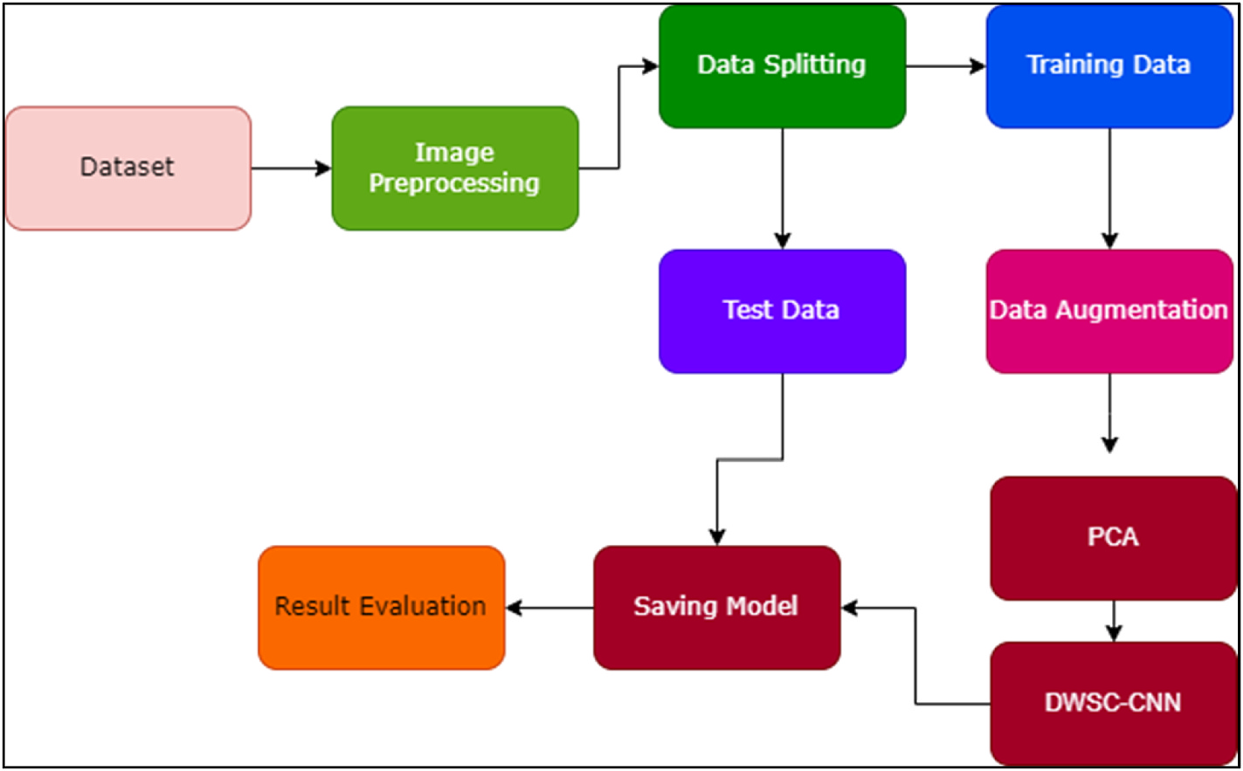

**Fig. 1.** Proposed workflow.

**Table 2**   
Parameters for data augmentation.

|  |  |
| --- | --- |
| Technique | Parameter |
| Rotation  Gaussian Blur (in %) Sharpness (in %)  Emboss (in %)  Shearing X and Y axis Gaussian Noise  Jitter  Flips | −30o to 30o  25, 50, 75, 100  50, 100, 150, 200  50, 100, 150, 200  10o  0.1 to 0.9  −4 to 4  Horizontal and Vertical |

information is preserved for deep learning, the extraction of picture features, and the categorization of images, but it also shortens the amount of time that is required for training and testing. In its most basic form, data dimensionality reduction is the process of mapping data from their original, high-dimensional space to their final, low-dimensional space destination. Depending on whether or not labels are used in the process, this procedure can be further broken down into nonlinear or linear or supervised or unsupervised dimensionality reduction. The principal component analysis (PCA) and the stacked autoencoder are the two dimensionality reduction components that are utilised in this research work.

*3.4.1. Principal component analysis (PCA)*   
 PCA is among the best approaches for dimensionality reduction in the area of unsupervised dimensionality reduction. Simply decomposing the data’s eigenvalues is all that is required to reach the objectives of data compression as well as the removal of redundancy. An image is another type of data that has a high degree of correlation. When it comes to the extraction of characteristics from pictures, PCA performs signifi-cantly better. The image matrix is subjected to a variety of processes, after which it is turned into an eigen subspace with less dimensions. After that, the covariance matrix is computed using the lower- dimensional matrix, as a starting point for computation. The covari-ance matrix is a representation of the relative variation that exists be-tween individual pixels in an image. After that, Eigen vectors are computed using the covariance matrix as a starting point. The Eigen vectors that have the highest values are the ones that are taken into consideration to be the principal components.

In PCA, every new feature is a linear combination of previous fea-tures, and it brings the total number of features from the original ‘*x*’

5

*S. Balasubaramanian et al.*  *Array 19 (2023) 100294*

|  |  |  |  |  |
| --- | --- | --- | --- | --- |
| *Cov*(*T*) = *TX*(*Tr*) = | { | *TX x*∗*y*  *Ty*∗*x* | }   *x*∗*x* | (4)  (5) |
| Eigen value is calculated by using equation (5). |*T* − *λ*| = 0 | | | |

where T is the matrix and *λ* is the eigen value.

Cov(T) is a big square matrix. Calculating the eigenvalue and eigenvector helps reduce the size of the mask/non-mask space vector, which improves both the efficiency and accuracy of the calculation. To achieve recognition, it is necessary to compute a weight, which is then compared with the weight of the test image. The following equation (6) helps to calculate the weight.

*ωn* = *λX*(*n* − *M*) (6)

Both the output layer and the input layer have the same data size in their respective scales. Fig. 2 represents the architecture of autoencoder.

The encoder’s output of the hidden layer feature, also known as the coding feature, may be thought of as a characterisation of the data D that was entered into the encoder. At the same time, the feature of the hidden layer is the feature that is acquired by the dimensionality reduction of the encoder. In this case, the data of the hidden layer H have a smaller dimensionality than the data of the input layer D and the data of the output layer Do; this is shown by the fact that |D| is greater than |H| and | Do| and that |D| is equal to |Do|. First, calculate H using the mapping matrix H = *x*(D), which will take you from the input layer D to the hidden layer H. Next, calculate Do using the mapping matrix Do = *y*(H), which will take you from the hidden layer H to the output layer Do. The transformation may be represented by equation (7).

*x* : *α* → *δ*

|  |  |  |  |
| --- | --- | --- | --- |
| where *ω* is the weight of image, *λ* is the eigen vector, X is the matrix and *M* is the mean value. | | *y* : *δ* →*α* | (7) |
| **Algorithm 1**. | Dimensionality Reduction | *x, y* = argmin ||*D* − *y*[*x*(*D*)]||2 |

1: Load the training data.

2: Compute mean value using equation (1)   
3: Compute data normalization using equation (2) 4: Find covariance-free matrix using equation (4) 5: Find Eigen vectors and values using equation (5) 6: For value in eigenvalue’s:   
7: Find the greatest eigenvalue.

8: Find the weight of image using equation (6)

*3.4.2. Stacked autoencoder (SAE)*   
 Encoding and decoding are the two parts that make up the Auto- Encoder (AE) model, which is a representation of an unsupervised neural network. During the encoding stage, the implicit properties of the input data are learned, and through the stage of decoding, the objective is to reproduce the correct data (input) by making use of the new fea-tures that have been learned. Because the neural network model can understand new features more correctly and carry out the job of feature extraction, the capacity to represent features in the data that is processed by AE is significantly improved. Only data that are equivalent to the training data can be compressed since the data that are created by AE are correlated with one another. A particular encoder is trained with the use of input from a particular class in order to accomplish the objective of autonomous learning from data samples. The purpose of the learning process in AE, which falls under the domain of unsupervised learning, is to restore input without the need of labelling. One may consider it to be composed of three layers: input layer, hidden layer, and output layer.

The magnitude of the hidden space, denoted by *δ*, is denoted by the letter *α*, which stands for the embedding input space (which is also known as the output space). The input space D is the element of *α* and the characteristic space H is the element of *δ* are both sent to the self- encoder, and it is its job to solve the mapping *(x, y)* that exists be-tween the two spaces in order to minimise the reconstruction error of the input feature.

There is a possibility that a single autoencoder will be unable to bring down the dimensionality of the input features. As a result, for situations like these, we make use of stacked autoencoders. As its name indicates, stacked autoencoders are a collection of encoders that are arranged in a vertical stack. The stacked autoencoder works based on the following principle.

i. Train the first autoencoder based on the input data, and then acquire the feature vector that was learnt.

ii. The feature vector from the previous layer is then utilised as the input for the layer that comes after it, and this process is continued until the training is finished.

iii. After all of the hidden layers have been trained, the back-propagation algorithm (BP) is utilised to perform fine-tuning. This is accomplished by minimising the cost function and updating the weights using labelled training sets.

*3.5. Development of deep learning architecture*

The architecture is developed as a less complex and effective

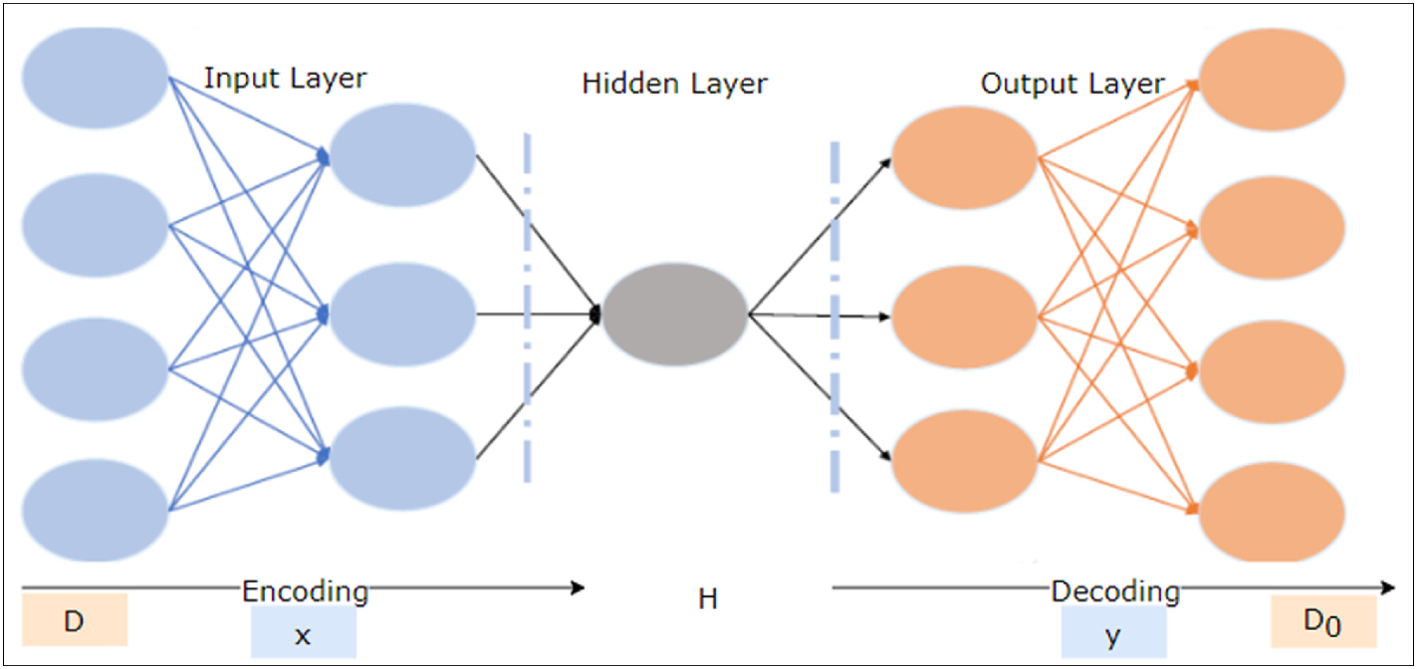

**Fig. 2.** Architecture of autoencoder.

6

*S. Balasubaramanian et al.*  *Array 19 (2023) 100294*

Convolutional Neural Network (CNN) model utilising libraries such as TensorFlow with Keras and the OpenCV to determine whether the test subjects are donning a face mask to protect themselves. The ‘work’s various aspects are all explained here. From the provided samples, the deep learning architecture begins to distinguish and classify several significant non-linear properties. To estimate the training pattern issues that are posed to it other than examples fed using the process depicted in Fig. 3, this informed architecture is employed. The pseudocode of the proposed DWSC-PCA-SAE algorithm is given below.

**Algorithm 2**. DWSC-PCA-SAE

• Input: Image files   
• Output: Mask or No-Mask 1: Load the dataset   
 2: Load OpenCV   
 3: Find the face in the datasets   
 4: Generate data augmentation   
 5: Perform PCA to reduce dimension   
 6: Build DWSC-CNN using Stacked Autoencoder 7: Load MobilNetv2   
 8: Train model   
 9: Test model   
 10: Classify the output

*3.5.1. Depth-wise separable convolutional neural network*   
 Fig. 3 provides a visual representation of the multi-layered charac-teristics, as well as a comparison between traditional and depth-wise separable features. When combined, the depth-wise (dw) and point-wise (pw) convoluted structures produce what is known as a “Depth- wise separable” convoluted structure. The standard convolutional structure is outperformed by the Depth-wise separable convolutional structure, which offers a function that is equivalent to the previous method but operates at a much quicker pace. Because the frames may be separated from one another in terms of depth, the offered approach does not have a pooling layer in between them. To minimise the impact of the spatial dimension, a few of the depth-wise layers each include a stride of two. In this instance, the collection of output channels is also included into the point-wise layer that comes after it.

*3.5.2. DSC-PCA-SAE architecture*   
 The CNN principles, which are essential for seeing patterns in pic-tures, are used in the learning model. The neural network must be able to view data from both classes. An input layer, many hidden layers, and

an output layer make up a network. There are several levels of convo-lution in hidden layers. Numerous dense neural networks employ the characteristics collected from CNNs for categorization. There are three pairs of convection levels in each of the 32 formations, followed by the highest pooling level. 100 kernels with a 3x3 window size and a maximum pooling level of 2x2 window size make up the convolution layer. The highest value inside the 2x2 frame will be chosen by this layer after combining the results of the preceding convolution level.

The number of parameters is decreased because of the local level of performance being decreased. The computations for the network become easier consequently. The resolution ‘evel’s output will be flat-tened and transformed into a 1-D array. Consequently, there are two thick layers and a dropout layer. The dropout layer eliminates the exclusion level drive to prevent network overfitting. Each neuron in the dense layer picks up nonlinear features as they are learned. The first dense layer of 50 knots will contain the flat outcome. Finally, there is another thick layer with two nodes that has two classes: one with a mask and the other without.

For unlabelled input, the autoencoder consists of two core models: an encoder and a decoder. The input feature map is encoded using an encoder, and then the feature map is decoded and rebuilt using a decoder module. For a more comprehensive modelling of the features in this study, it squeezed the output feature vector from the MobileNetV2 model using the encoder function of the stacked autoencoder. Global average pooling is used to decrease the output dimensions of the MobileNetV2 model, which are 7 × 7 × 1280, to 1280 dimensions. The suggested encoding technique is then given access to the output of the global average pooling to further extract more representative compo-nents for the last stage classification. The features vectors 1280 di-mensions are first converted to 640 and then to 320 dimensions. The autoencoder complexity is mostly decreased by feature encoding uti-lising their halves.

In this research work, it employed stacked auto-encoding layers to reduce the size of the MobileNetV2 output feature vector while main-taining an abstract representation of all feature mappings. To use ReLU and softmax in a stacked autoencoder, it typically applies the ReLU activation function to the hidden layers of the encoder and decoder, and apply the softmax activation function to the output layer of the decoder when the task is multi-class classification. The weights, which include a bias term and an ReLU activation function (given in equation (8)) are multiplied with the data in the stacked autoencoder encoding module.

ReLU : f(n) = max(0*,* n) (8)

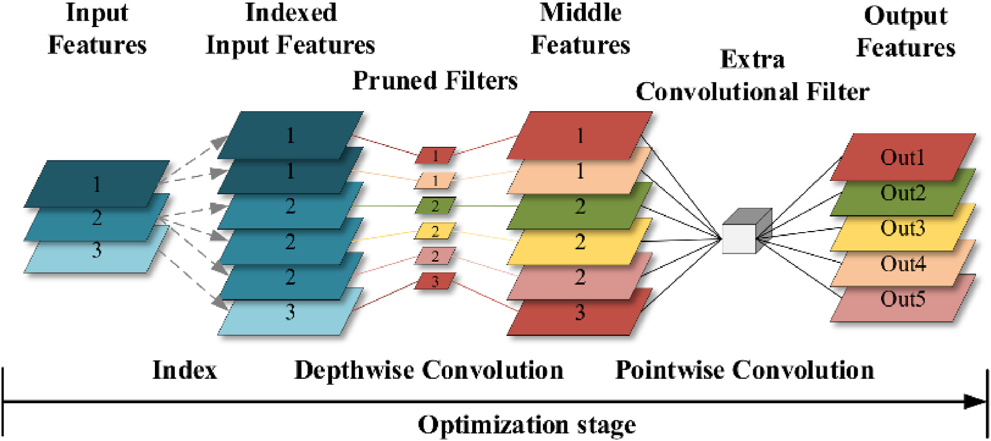

**Fig. 3.** Architecture of depth-wise convolutional neural network.

7

*S. Balasubaramanian et al.*  *Array 19 (2023) 100294*

where ‘n’ represents the positive value return by the function and false positive return ‘0’. The value of rectified linear unit is between ‘0’ to infinity.

The first encoding layer in the suggested stacked encoded layers employs MobileNetV2’s output feature vector, while the next layer stacks feature from the first layer. To understand the encoded charac-teristics before the classification layer, two fully linked (Dense) layers receive the output of the encoding layers. In the output layer, softmax is used as the activation function and it is given in equation (9).

|  |
| --- |
| *softmax* ( *nj* ) =exp  ∑exp (*nk*) ( *nj* ) (9)  where k is the number of classes. This means that for each class j, we take  the exponent of the input nj and divide it by the sum of the exponentials |

of all the inputs. This ensures that the outputs add up to one, and can be interpreted as probabilities of each class.

The overall proposed model can be expressed mathematically in equation (10).

|  |  |  |  |
| --- | --- | --- | --- |
| *y* = *f*(*W*2 | ◦ *f*(*W*1 | ◦*Px* + *b*1) + *b*2) | (10) |

where:

• y is the binary classification output indicating whether the input image contains a mask or not.

• P is the PCA projection matrix of size (HWC) x k. H-Height, W-Width and C-number of channels.

• x is the PCA pre-processed image.

• W1 and W2 are the weight matrices of the DSCNN model.

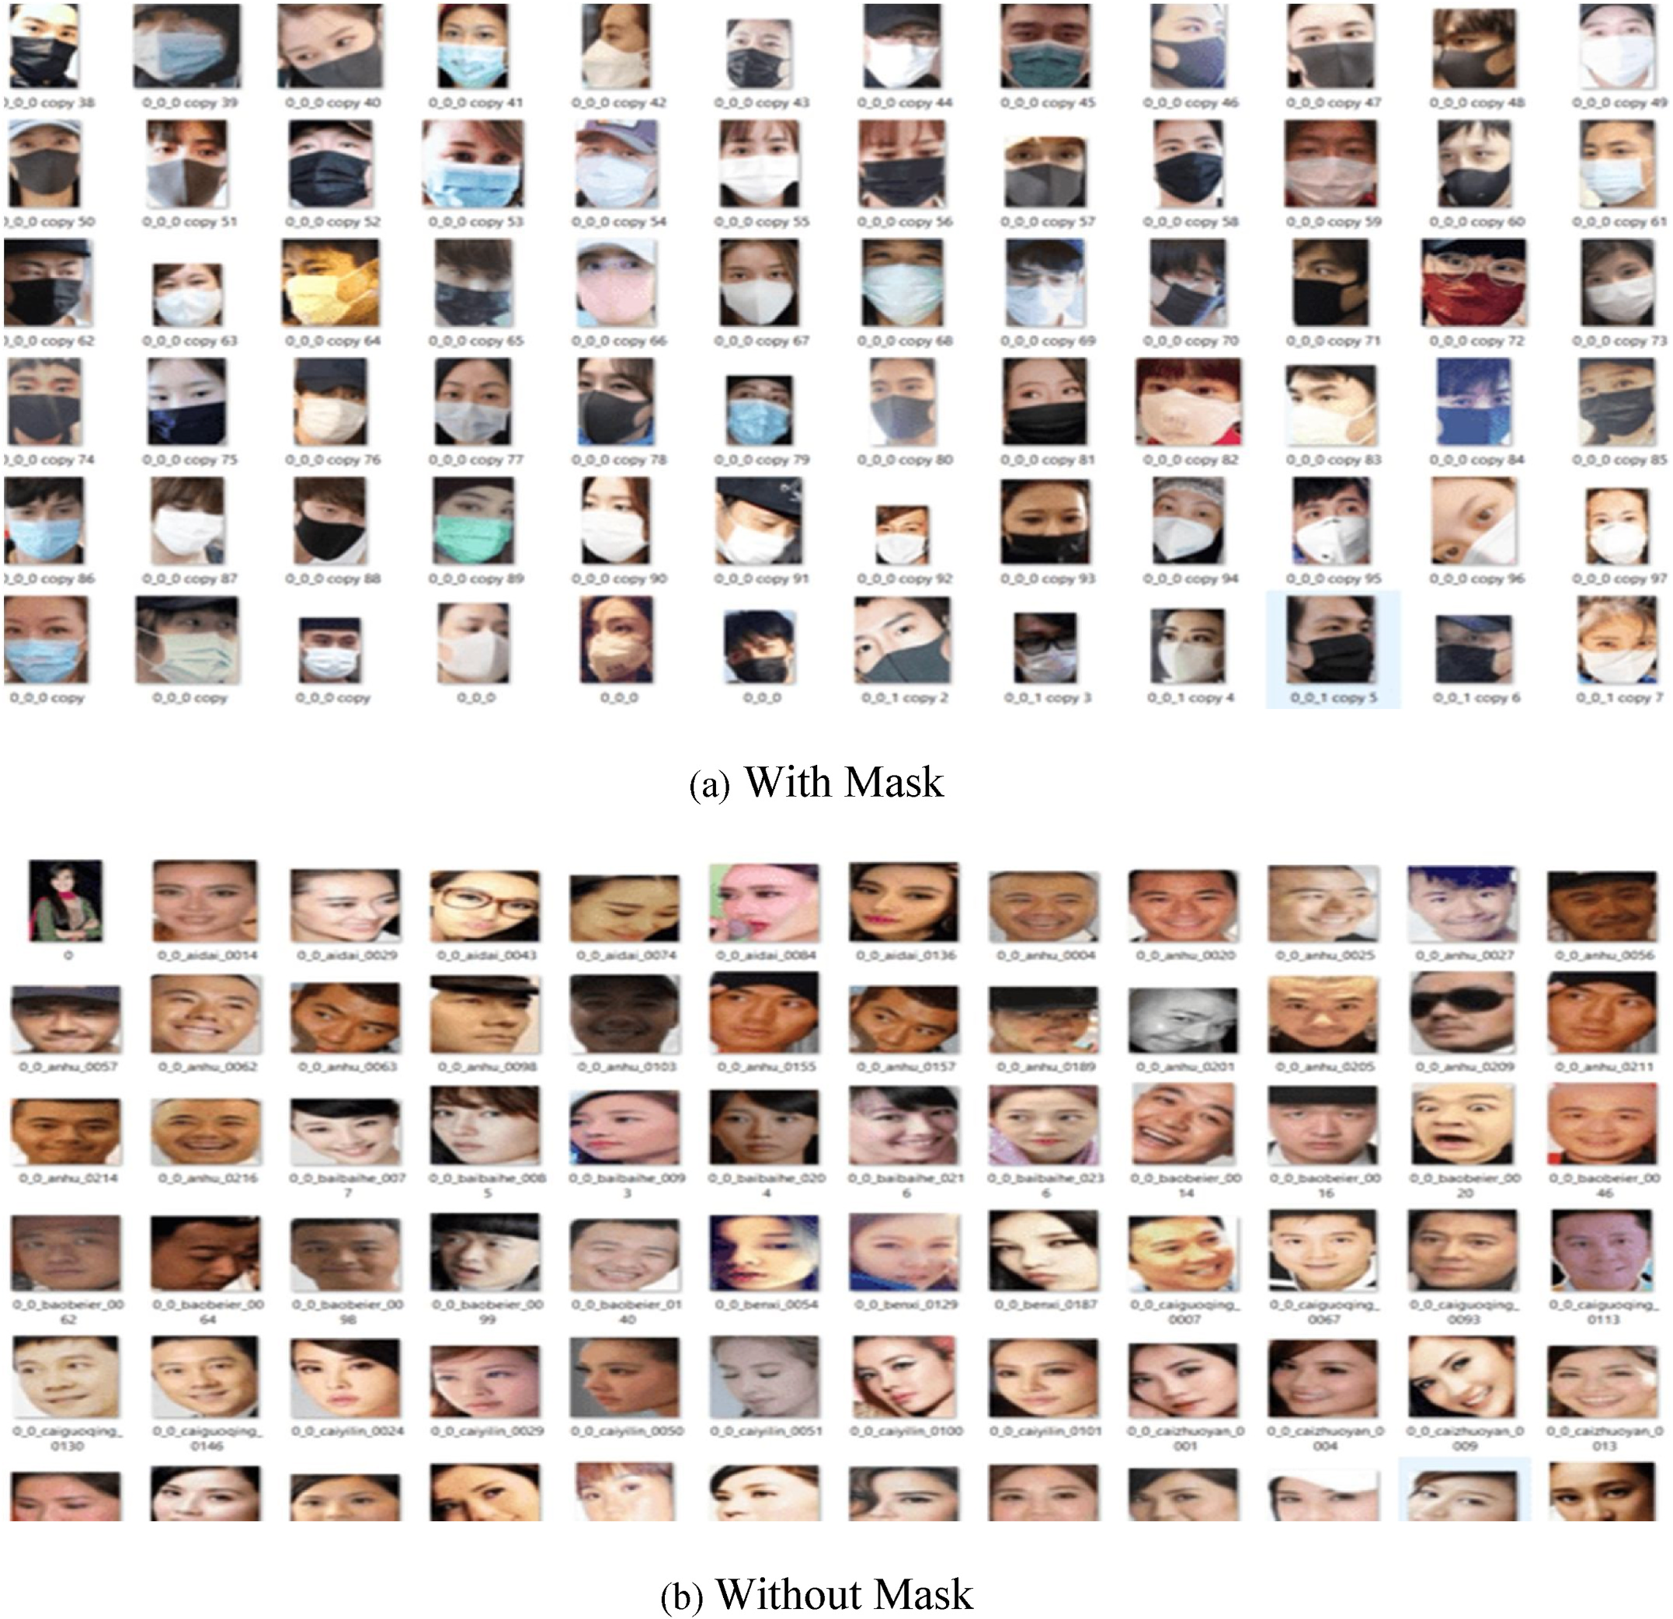

**Fig. 4.** Dataset bifurcation in categories (a) with-mask, (b) without-mask.

8

*S. Balasubaramanian et al.*  *Array 19 (2023) 100294*

• b1 and b2 are the bias vectors of the DSCNN model. • f is the activation function.

• + denotes element-wise addition.

•◦denotes element-wise multiplication.

**4. Results and disscussions**

*4.1. Dataset description*

For training the proposed deep learning model, it has gathered a variety of photos. CNN plays a significant role in the learning strategy’s framework. The dataset consists entirely of facial photos. It comprises 658 pictures in the category without masks and 670 pictures in the category with masks. Ninety percent of the photos in each class are used for training, while the remaining ten percent of each dataset are utilised for testing. The numerous objects under each category—with mask and without mask—are shown in Fig. 4.

The outcomes of the experiment are thoroughly explained in this section. The Keras framework with TensorFlow as the backend is used for all experiments, which runs on a GPU with 64 GB of RAM. The datasets utilised for each model’s assessment, evaluation metrics, are all included in this part. The further sections provide a brief description of each of these sections.

*4.2. Evaluation metrics*

The comparison of the effectiveness of proposed algorithm makes use of a confusion matrix. By combining the values of True Negative (TN), True Positive (TP), False Negative (FN), and False Positive (FP), this matrix is used to generate various metrics. The performance metrics used to assess models using the confusion matrix are listed below.

Accuracy is a measure of a model’s estimated value corresponds to its real or actual value, which corresponds to the proportion of all samples that are properly categorised. The model’s accuracy is determined using the following formula:

|  |
| --- |
| *Accuracy* = *TP* + *TN* + *FP* + *FN*  *TP* + *TN*  (11)  Precision reveals the proportion of relevant occurrences among the chosen examples that are truly affirmative. To determine accuracy, apply the formula below:  *Precision* = *TP* + *FP*  *TP*  (12)  The percentage of genuine positives that are accurately detected is determined by recall or true positive rate (TPR). The following equation is used to calculate recall:  *Recall* = *TP* + *FN*  *TP*  (13)  The harmonic mean of accuracy and memory, which sums the weighted average of precision and recall, is how the F1 score is often understood. The F1-score is calculated using the following formula:  *F* − *Score* =*Precision* ∗ *Recall Precision* + *Recall*  (14)  The proposed work is experimented using Windows 10 computer, an Intel Core i5 processor, and Nvidia GTX 1080 GPU for the tests. Pro-gramming was carried out using Python 3.8. The pre-trained model is using 224x3 STIF frames. The proposed approach is tested using this dataset. Datasets for training and testing have been produced. The scaling factor was first set at 0.001, and after that, it decreases by a factor of 0.9 every 10 epochs. The Adam optimizer uses a momentum value of 0.999. The training process is repeated up till 100 epochs have transpired. The layout of the recommended MobileNetV2 parameter settings for efficient face picture classification (mask/no-mask) is used. |

9

*S. Balasubaramanian et al.*  *Array 19 (2023) 100294*

**Table 4**   
Comparative Analysis of proposed method with existing methods.

|  |  |  |  |  |
| --- | --- | --- | --- | --- |
|  | Precision | Recall | F-Score | Accuracy |
| AlexNet  Proposed | 0.966587 0.976134 | 0.935335 0.944573 | 0.950704 0.960094 | 0.927959 0.941681 |

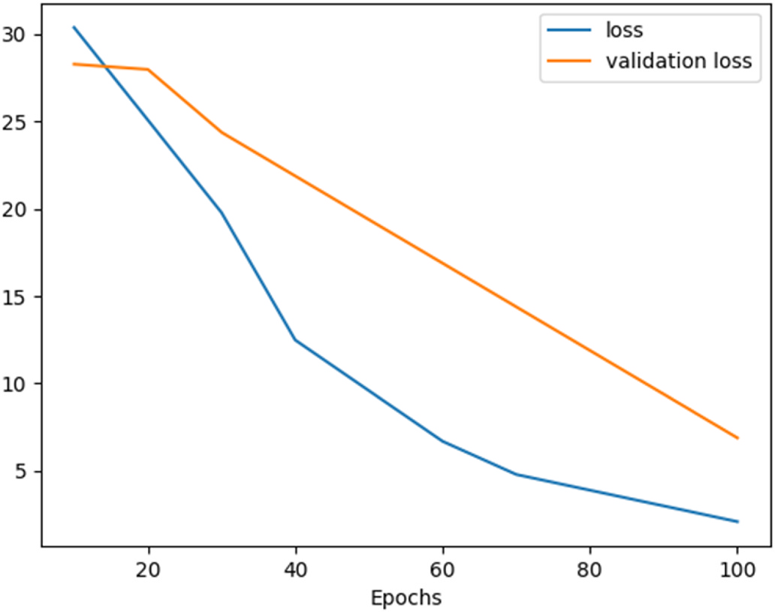

**Fig. 5.** Results of training loss and validation loss – without data augmentation.

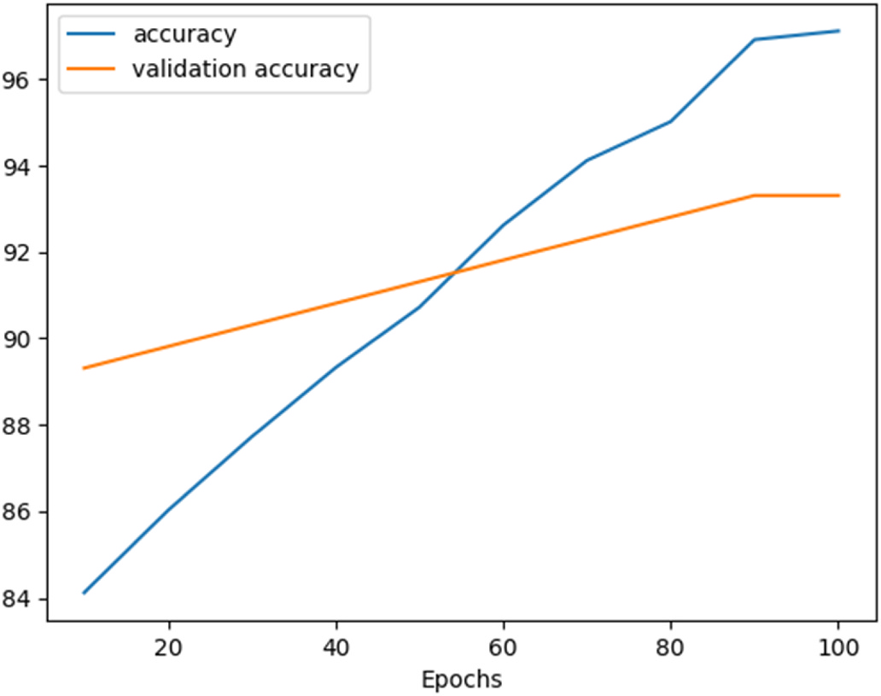

**Fig. 6.** Results of accuracy and validation accuracy – without data augmentation.

evaluates the results of the research in comparison to the original con-volutional filters. According to the findings of the trials, the proposed system performed much better than the existing conventional convolu-tions. In addition, past work on a motivated baseline approach is compared with the strategy that has been offered here. According to the results, which include an accuracy score of 94.1%, a precision score of 97.6%, a recall score of 94.4%, and an F-score of 96.01%. The DWSC- PCA-SAE algorithm generates the greatest overall performance across a range of evaluation criteria. This model needs additional processing to create visualisations, and due to the limitations of the dataset, it is un-able to differentiate between appropriate and inappropriate mask application. In the future, one of our goals is to provide face mask identification datasets that include a variety of various mask wearing

10

*S. Balasubaramanian et al.*  *Array 19 (2023) 100294*

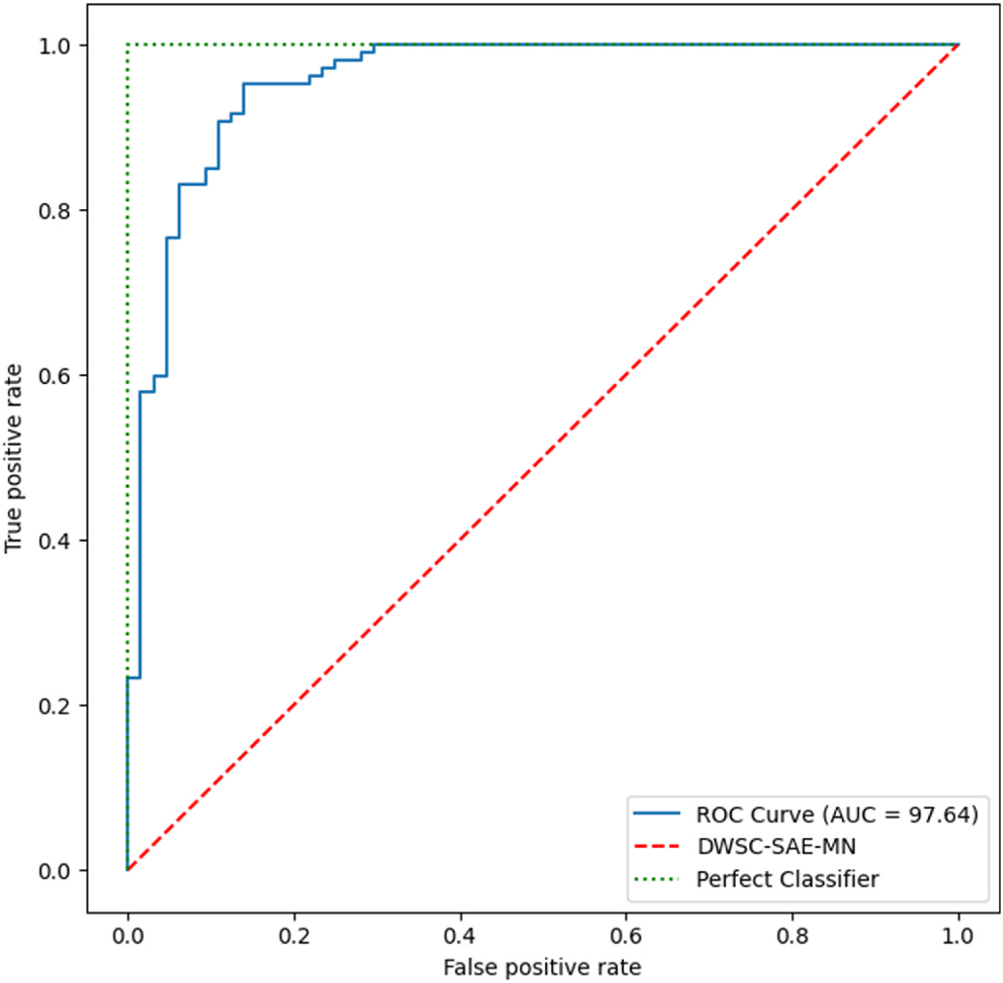

**Fig. 10.** Comparison of true positive rate with false positive rate.

states. Alternatively, in the future, the work needs to use zero-shot learning to have the design recognise incorrect mask wearing states.

**Authorship statement**

All persons who meet authorship criteria are listed as authors, and all authors certify that they have participated sufficiently in the work to take public responsibility for the content, including participation in the concept, design, analysis, writing, or revision of the manuscript. Furthermore, each author certifies that this material or similar material has not been and will not be submitted to or published in any other publication before its appearance in the *Array-Open Access-Elsevier*.

**Authorship contributions**

Category 1   
 Sundaravadivazhagan Balasubaramanian, Robin Cryic: Conception and design of study, Robin Cyriac, Sahana Roshan, Boby Chellanthara Jose,: Acquisition of data, Sundarvadivazhagan Balasubaramanian, Kulandaivel Maruthamuthu Paramasivam: analysis and/or interpreta-tion of data.

Category 2   
 Drafting the manuscript: Kulandaivel Maruthamuthu Paramasivam, Boby Chellanthara Jose, revising the manuscript critically for important intellectual content: Sundarvadivazhagan Balasubaramanian, Robin Cyriac.

Category 3   
 Approval of the version of the manuscript to be published (the names of all authors must be listed):   
 Sundarvadivazhagan Balasubaramanian, Robin Cyriac, Sahana Roshan, Kulandaivel Maruthamuthu Paramasivam, Boby Chellanthara Jose.

**Declaration of competing interest**

The authors declare the following financial interests/personal re-lationships which may be considered as potential competing interests: Sundaravadivazhagan Balasubaramanian reports financial support was provided by University of Technology and Applied Sciences - Al

11

*S. Balasubaramanian et al.*  *Array 19 (2023) 100294*

[19] Qin B, Li D. Identifying facemask-wearing condition using image super-resolution with classification network to prevent covid-19. Sensors 2020;20(18):5236.

<https://doi.org/10.3390/s20185236>.

[20] [Li C, Wang R, Li J, Fei L. Face detec](https://doi.org/10.3390/s20185236)tion based on yolov3. In: Recent trends in intelligent computing, communication and devices. Springer; 2020. p. 277–84. <https://doi.org/10.1007/978-981-13-9406-5 34>.

[21] [Ochin S. Deep challenges associated with deep](https://doi.org/10.1007/978-981-13-9406-5 34) learning. In: 2019 International conference on machine learning, big data, cloud and parallel computing (COMITCon). IEEE; 2019. p. 72–5. [https://doi.org/10.1109/](https://doi.org/10.1109/COMITCon.2019.8862453)   
[COMITCon.2019.8862453](https://doi.org/10.1109/COMITCon.2019.8862453).

[22] [Chen Y, Hu Menghan, Hua](https://doi.org/10.1109/COMITCon.2019.8862453) C, Zhai G, Zhang J, Li Q, Yang SX. Face mask assistant: detection of face mask service stage based on mobile phone. IEEE Sensor J 2021;21 (9):11084–93. <https://doi.org/10.1109/JSEN.2021.3061178>.

[23] Venkateswarlu [IB, Kakarla J, Prakash S. Face mask detection](https://doi.org/10.1109/JSEN.2021.3061178) using mobilenet and global pooling block. In: 2020 IEEE 4Th conference on information &

12